**Mehul Raj**

**Verzeo Data Science September Batch**

**Email:** [mehulraj1995@gmail.com](mailto:mehulraj1995@gmail.com)

**Verzeo Mini Project**

**Problem Statement:**

Predict the number of passengers in the airline using time series analysis.

Using the Model used Fbprophet.

**Working:**

1. The working starts with changing the names of columns and data type for month (or ds) column.

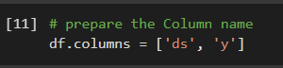



1. Modelling using fbprophet model to fit the dataset.

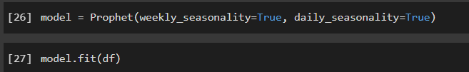

1. Model Predicton using future dataframe that has been developed seeing the last date on Main dataset and making some test dataset.

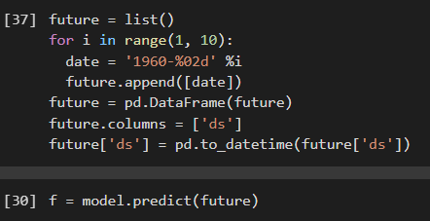

1. Plotting the components for evaluation:

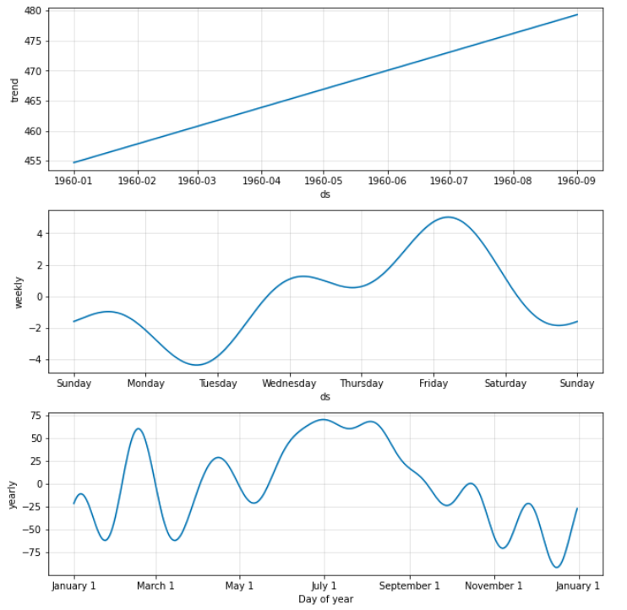

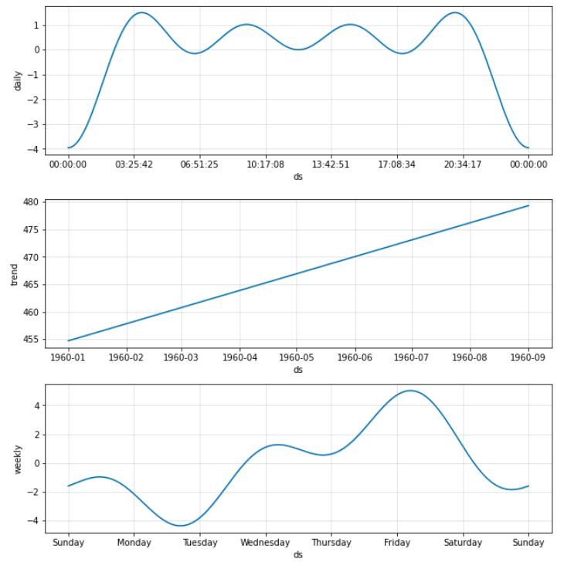

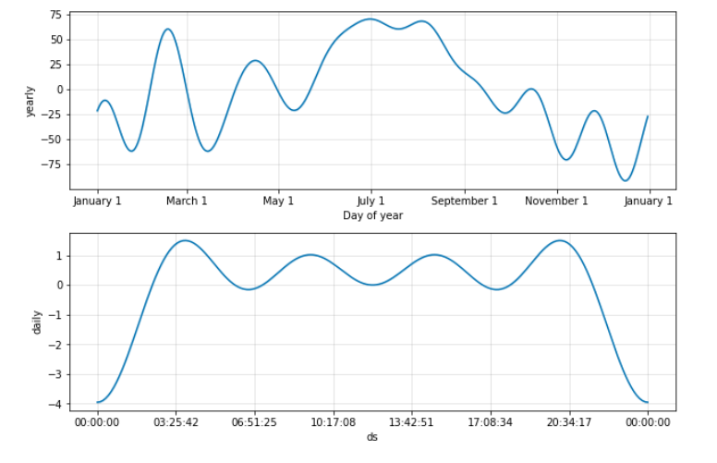

1. Finally, seeing the model predicted results:

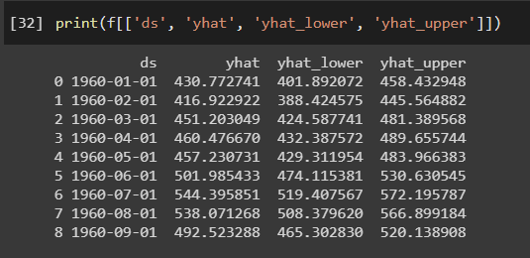

**GitHub URL:**

<https://github.com/mehulraj19/Verzeo-Mini-Project>